Batch: A2 Roll No.: 16010122034
Experiment No. 4
Grade: AA / AB / BB / BC / CC / CD /DD

Title: Implementation of different operations on Linked List – creation, insertion, deletion, traversal, searching an element

Objective: To understand the advantage of linked list over other structures like arrays in implementing the general linear list

Expected Outcome of Experiment:

CO | Outcome
CO 1 | To understand the advantage of linked list over other structures like arrays in implementing the general linear list

Books/ Journals/ Websites referred:
∙ www.geeksforgeeks.com
∙ www.javapoint.com
∙ www.leetcode.com

Introduction:
A linear list is a list where each element has a unique successor. There are four common operations associated with linear list: insertion, deletion, retrieval, and traversal. Linear list can be divided into two categories: general list and restricted list. In general list the data can be inserted or deleted without any restriction whereas in restricted list there is restrictions for these operations. Linked list and arrays are commonly used to implement general linear list. A linked list is simply a chain of structures which contain a pointer to the next element. It is dynamic in nature. Items may be added to it or deleted from it at will.
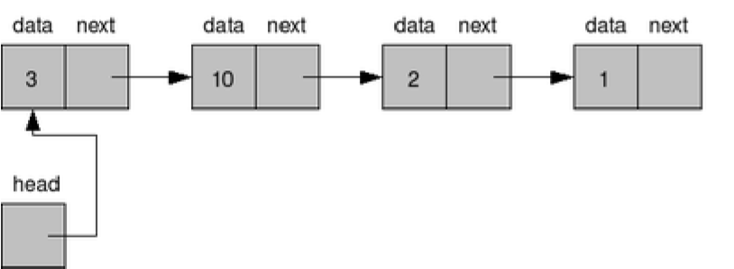
A list item has a pointer to the next element, or to NULL if the current element is the tail (end of the list). This pointer points to a structure of the same type as itself. This Structure that contains elements and pointers to the next structure is called a Node.
Related Theory: -
In computer science, a linked list is a linear collection of data elements, whose order is not given by their physical placement in memory. Instead, each element points to the next. It is a data structure consisting of a collection of nodes which together represent a sequence. In its most basic form, each node contains: data, and a reference to the next node in the sequence. This structure allows for efficient insertion or removal of elements from any position in the sequence during iteration.
Like arrays, Linked List is a linear data structure. Unlike arrays, linked list elements are not stored at contiguous location; the elements are linked using pointers

Linked List ADT:
#include <stdio.h>
#include <stdlib.h>

struct node
{
int info;
struct node *ptr;
}*top,*top1,*temp;

void push(int data);
void pop();
void display();
void stack_count();
void create();

int count = 0;

void main()
{
int no, ch, e;

printf("\n 1 - Push");
printf("\n 2 - Pop");
printf("\n 3 - Display");
printf("\n 4 - Exit");

create();

while (1)
{
printf("\n Enter choice : ");
scanf("%d", &ch);

switch (ch)
{
case 1:
printf("Enter data : ");
scanf("%d", &no);
push(no);
break;
case 2:
pop();
break;
case 3:
display();

break;
case 4:
exit(0);
default :
printf(" Wrong choice, Please enter correct choice ");
break;
}
}
}

void create()
{
top = NULL;
}

void stack_count()
{
printf("\n No. of elements in stack : %d", count);
}

void push(int data)
{
if (top == NULL)
{
top =(struct node *)malloc(1*sizeof(struct node));
top->ptr = NULL;
top->info = data;
}
else
{
temp =(struct node *)malloc(1*sizeof(struct node));
temp->ptr = top;
temp->info = data;
top = temp;
}
count++;
}

void display()
{
top1 = top;

if (top1 == NULL)
{

printf("Stack is empty");
return;
}

while (top1 != NULL)
{
printf("%d ", top1->info);
top1 = top1->ptr;
}
}

void pop()
{
top1 = top;

if (top1 == NULL)
{
printf("\n Error : Trying to pop from empty stack");
return;
}
else
top1 = top1->ptr;
printf("\n Popped value : %d", top->info);
free(top);
top = top1;
count--;
}

OUTPUT
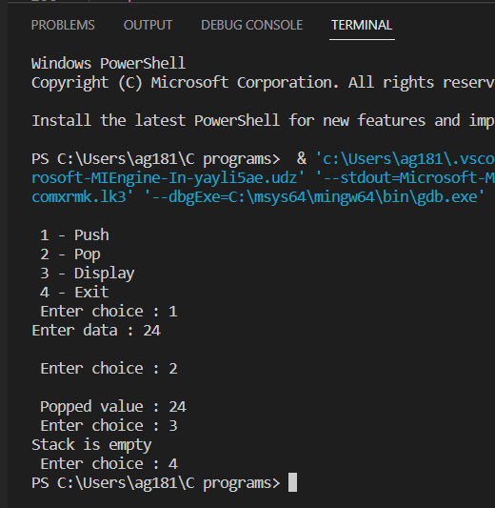

Algorithm for creation, insertion, deletion, traversal and searching an element in assigned linked list type:
Define a 'Node' structure with two members data and next.
Step 3 - Define a Node pointer 'top' and set it to NULL.
Step 4 - Implement the main method by displaying Menu with list of operations and make suitable function calls in the main method.
PUSH
We can use the following steps to insert a new node into the stack...
Step 1 - Create a top with given value.
Step 2 - Check whether stack is Empty (top == NULL)
Step 3 - If it is Empty, then set top → ptr = NULL.
Step 4 - If it is Not Empty, then set top → ptr
Step 5 - Finally, set top = newNode.

PUSH
We can use the following steps to delete a node from the stack...
Step 1 - Check whether stack is Empty (top == NULL).
Step 2 - If it is Empty, then display "Stack is Empty!!! Deletion is not possible!!!" and terminate the function
Step 3 - If it is Not Empty, then define a Node pointer 'temp' and set it to 'top'.
Step 4 - Then set 'top = top → next'.
Step 5 - Finally, delete 'temp'
DISPLAY
We can use the following steps to display the elements (nodes) of a stack...
Step 1 - Check whether stack is Empty (top == NULL).
Step 2 - If it is Empty, then display 'Stack is Empty!!!' and terminate the function.
Step 3 - If it is Not Empty, then define a Node pointer 'temp' and initialize with top.
Step 4 - Display 'temp → data --->' and move it to the next node. Repeat the same until temp reaches to the first node in the stack. (temp → next != NULL).
Step 5 - Finally! Display 'temp → data ---> NULL'.

Implementation of an application using linked lists:
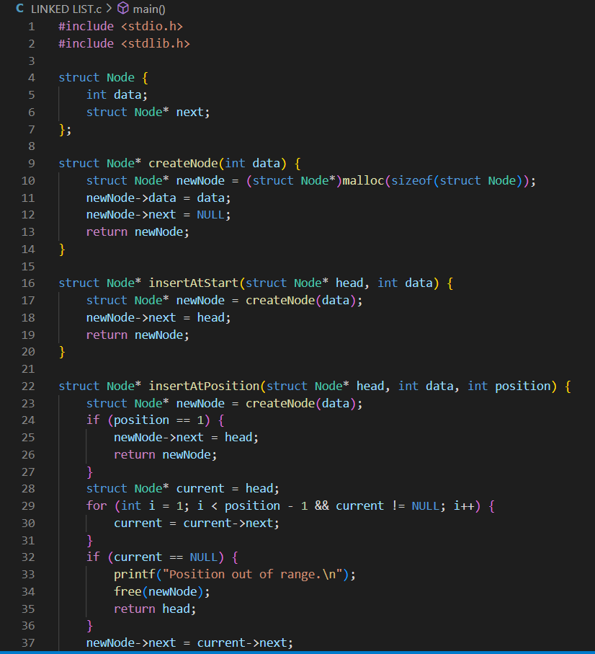

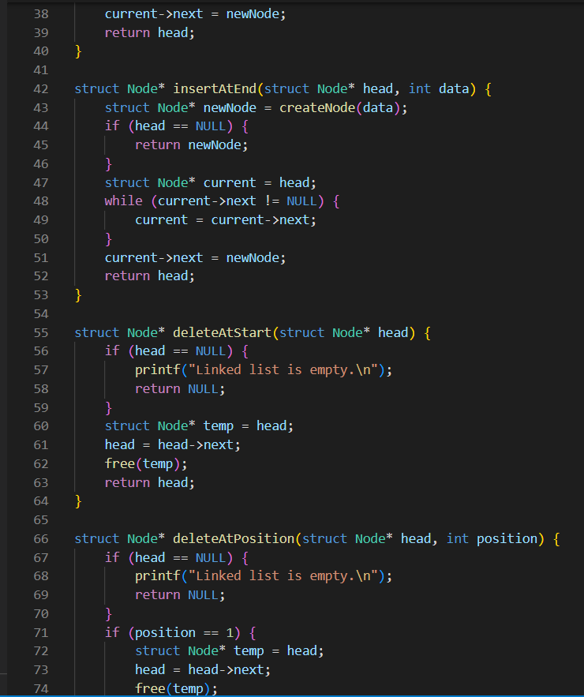

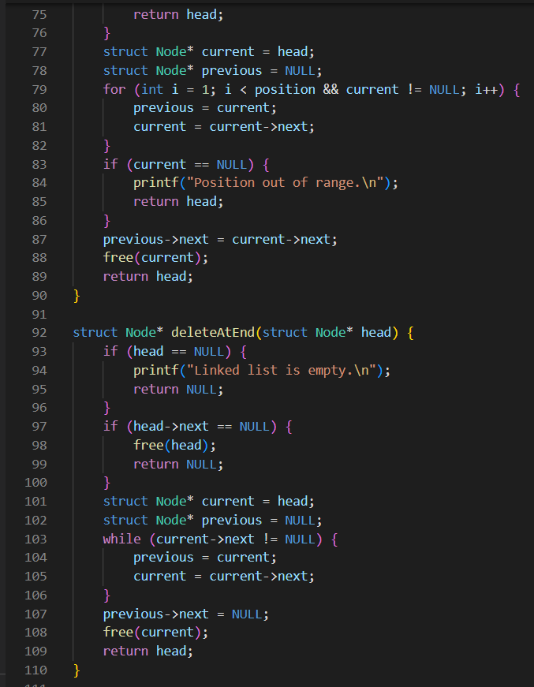

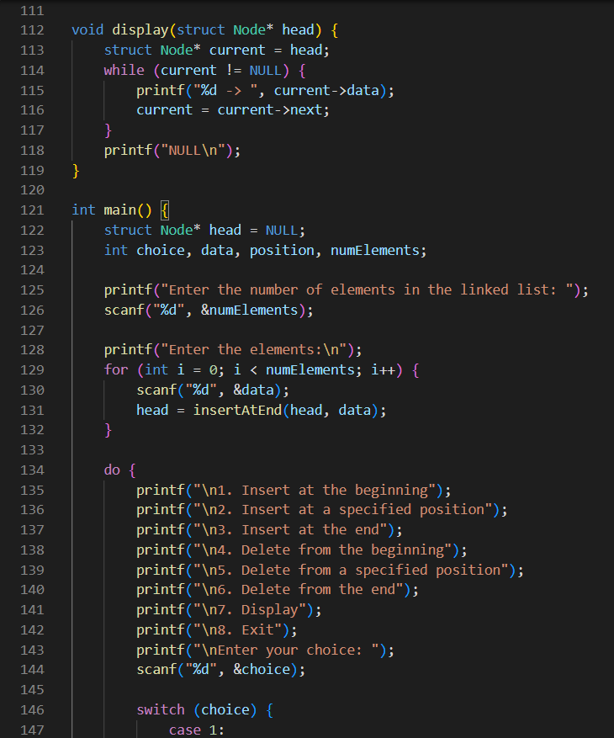

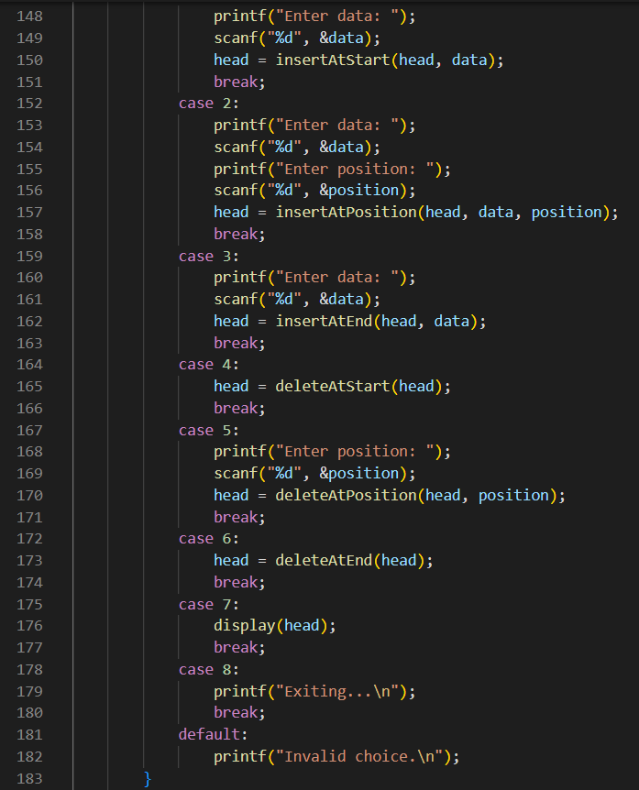
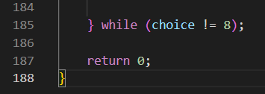

OUTPUT
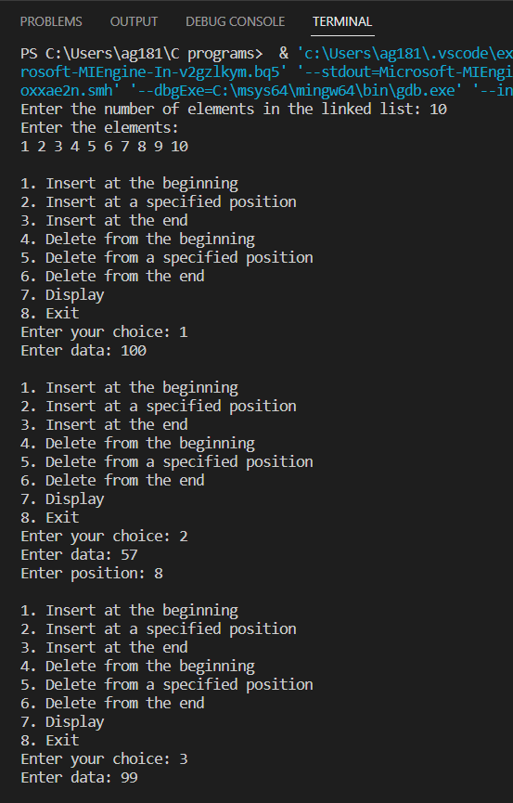

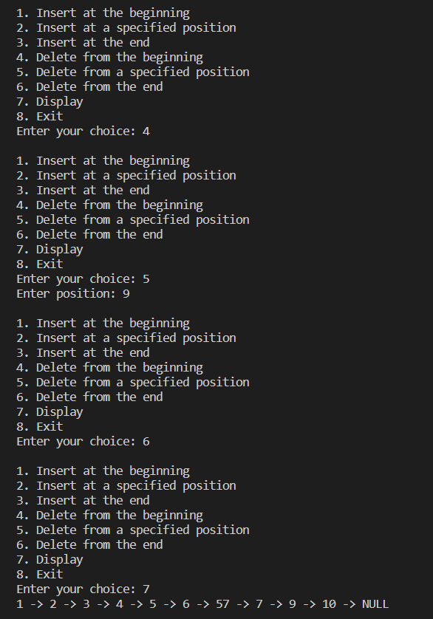
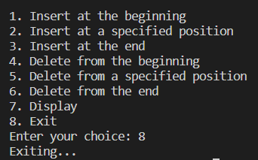
Conclusion:-
Successfully completed stack operations using both array and linked list.

Post lab questions:
1. Write the differences between linked list and linear array
An array is a grouping of data elements of equivalent data type. | A linked list is a group of entities called a node. The node includes two segments: data and address.
It stores the data elements in a contiguous memory zone. | It stores elements randomly, or we can say anywhere in the memory zone.
In the case of an array, memory size is fixed, and it is not possible to change it during the run time. | In the linked list, the placement of elements is allocated during the run time.
The elements are not dependent on each other | The data elements are dependent on each other.
The memory is assigned at compile time. | The memory is assigned at run time.
It is easier and faster to access the element in an array. | In a linked list, the process of accessing elements takes more time.
In the case of an array, memory utilization is ineffective. | In the case of the linked list, memory utilization is effective.
When it comes to executing any operation like insertion, deletion, array takes more time. | When it comes to executing any operation like insertion, deletion, the linked list takes less time.

2. Name some applications which use a linked list.
- Polynomial Manipulation
- Addition of long +ve integers
- Symbol table creation
- Memory management
- Allocation of files

